**Artificial Intelligence Lab**

**Name** - N Aditya Sai

**Register Number**- RA1911030010075

**Topic**: Implementation of Knowledge Representation Schemes

**Experiment** – 8

**Aim:** To implement the given knowledge representation schemes in GUI Prolog

**Code:**

go :- hypothesize(Animal),

write('I guess that the animal is: '),

write(Animal),

nl,

undo.

hypothesize(cheetah) :- cheetah, !.

hypothesize(tiger) :- tiger, !.

hypothesize(giraffe) :- giraffe, !.

hypothesize(zebra) :- zebra, !.

hypothesize(ostrich) :- ostrich, !.

hypothesize(penguin) :- penguin, !.

hypothesize(albatross) :- albatross, !.

hypothesize(unknown).

cheetah :- mammal,

carnivore,

verify(has_tawny_color),

verify(has_dark_spots).

tiger :- mammal,

carnivore,

verify(has_tawny_color),

verify(has_black_stripes).

giraffe :- ungulate,

verify(has_long_neck),

verify(has_long_legs).

zebra :- ungulate,

verify(has_black_stripes). ostrich :- bird,

verify(does_not_fly), verify(has_long_neck).

penguin :- bird,

verify(does_not_fly),

verify(swims),

verify(is_black_and_white).

albatross :- bird,

verify(appears_in_story_Ancient_Mariner),

verify(flys_well).

mammal :- verify(has_hair), !.

mammal :- verify(gives_milk).

bird :- verify(has_feathers), !.

bird :- verify(flys),

verify(lays_eggs).

carnivore :- verify(eats_meat), !.

carnivore :- verify(has_pointed_teeth),

verify(has_claws),

verify(has_forward_eyes).

ungulate :- mammal,

verify(has_hooves), !.

ungulate :- mammal,

verify(chews_cud).

ask(Question) :-

write('Does the animal have the following attribute: '),

write(Question),

write('? '),

read(Response),

nl,

( (Response == yes ; Response == y)

->

assert(yes(Question)) ;

assert(no(Question)), fail).

:- dynamic yes/1,no/1.

verify(S) :- (yes(S) -> true ; (no(S) ->

fail ; ask(S))). undo :- retract(yes(_)),fail.

undo :- retract(no(_)),

fail.

undo.

**Output:**

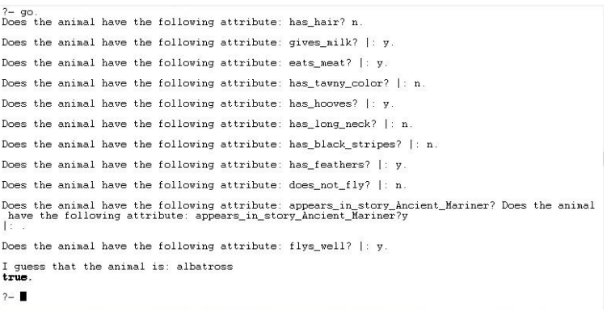

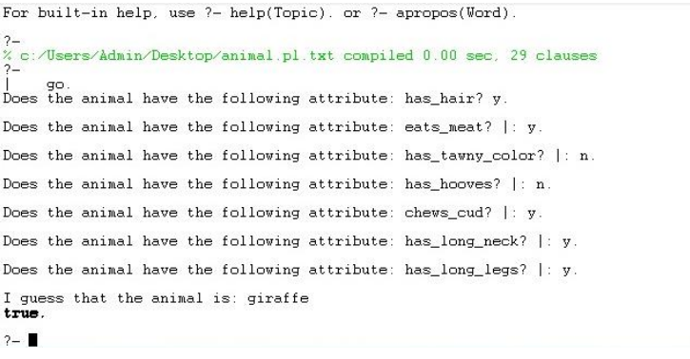

**Result:** The following knowledge representation schemes have been successfully implemented in GUI Prolog.